**The class Car with 2 data members: owner and price is given and you do not need to edit it.**

**The MyList class is a linked list of Car objects.**

**The following methods should be completed:**

**• def addLast(self, name, price) - check if name start with = 'B' or price >100 then do nothing,**

**otherwise add new car with Name=name, Price=price, to the end of the list. (Price can get**

**arbitrary value, even negative).**

**Input.txt**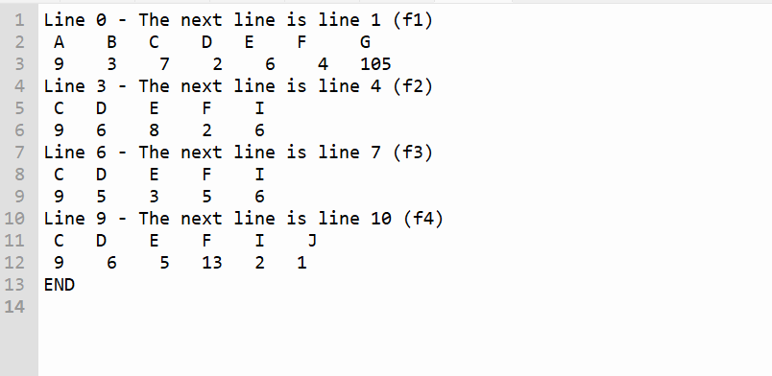

**Q1.1**

**Test the addLast methode**

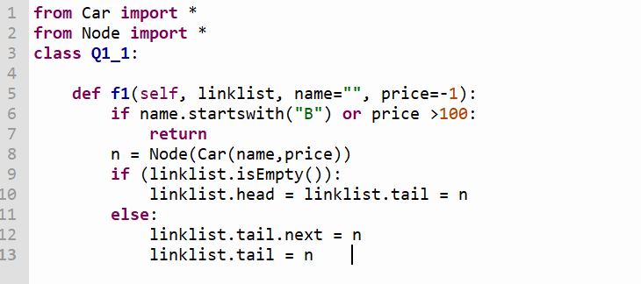

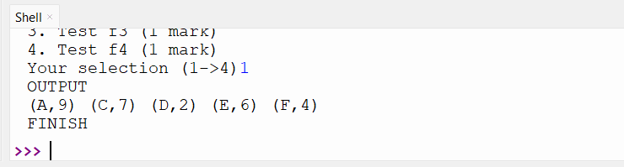

**Q1.2**

**The first element of the list.**

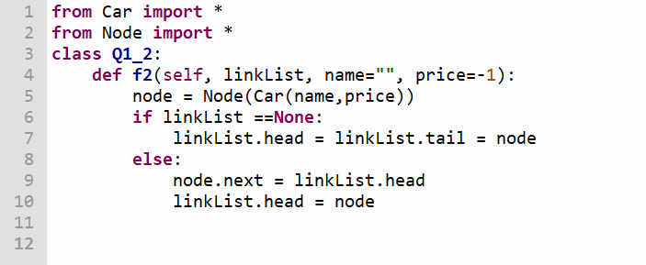

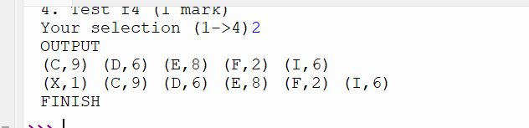

**Q1.3**

**Delete the first node having price=5.**

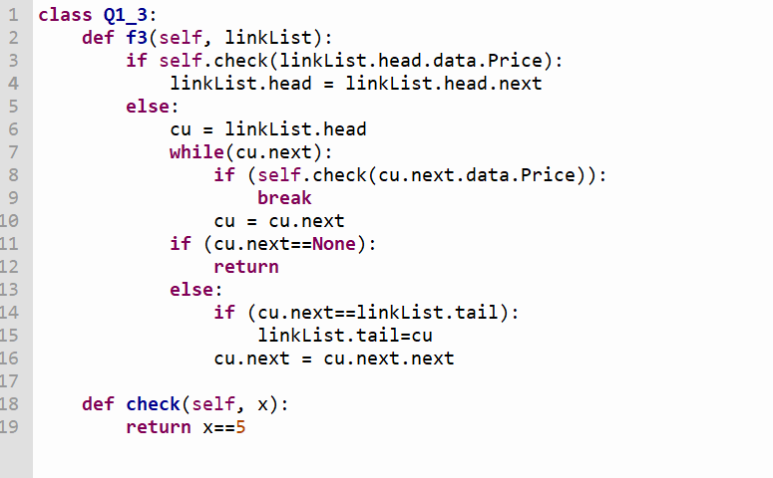

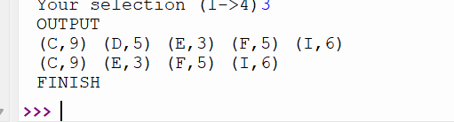

**Q1.4**

**Sort the list ascendingly by price.**

